**CONTRACT 01064**

**DIGITAL ADVISORY SERVICES**

**TENDER BRIEF**

**Dated**

September 2024

# Contents

Contents 2

1.0 Introduction 3

2.0 Key Goal 5

3.0 Scope 5

4.0 Brief of Services 5

4.1 Service Scope 5

4.2 Industry Coverage 5

4.3 Service Deliverables 5

4.4 Client Engagement and Support 6

4.5 Tools and Resources 6

4.6 Performance Metrics and Reporting 6

4.7 Compliance and Security 6

4.8 Cost and Payment Terms 7

4.9 Evaluation and Continuous Improvement 7

4.10 Case Studies and References 7

5.0 Definitions 7

6.0 Occupational Health and Safety requirements 7

6.1 General Occupational Health and Safety requirements 7

6.2 Legislative compliance 8

6.3 Consultant OHS Management Systems 8

6.4 Incident notification 8

6.5 Corrective action 8

7.0 Privacy Disclosure 9

8.0 Invoicing 9

9.0 Relationship management 9

10.0 Insurance 9

11.0 Pricing 9

12.0 Submission 9

13.0 General Terms and Conditions 10

14.0 Contract Term 10

15.0 GST 10

16.0 Meetings 10

17.0 Schedule of Performance Standards 11

# Introduction

Every day, we supply Southwest Victoria with sustainable water services, while leading our communities towards a healthier, more prosperous future. It’s a commitment that we’re proud to make to the region we call home.

**We’re local, dependable experts**

From the South Australian border to the Otways. From the Grampians to the coast. Our services take care of more than 30 communities, including residents, farmers, businesses and industries. It’s our responsibility to supply our customers with fresh water, from source to tap, and manage sewage to protect their health and wellbeing.

Putting people first comes naturally to us so we’re here to help with more affordable, reliable and personalised service. You’ll see us around, in towns and on streets, maintaining and upgrading the pipes, pump stations and treatment plants we all need.

**We’re making a real and positive difference**

As locals, we’re driven to shape our region for the better. We’re committed to working with our communities and strategic partners to support the health and wellbeing of our people and protect our natural environment. We simply believe it’s the right thing to do and it all comes back to our greater vision to go beyond water for stronger communities.

It’s about delivering sustainable water services together with positive change for our region – and we’re proud to be leading the way.

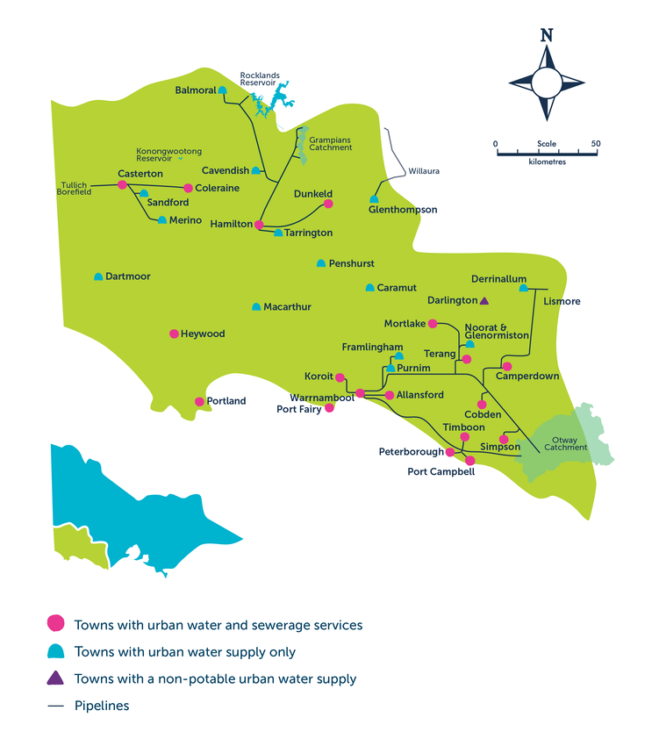

# Key Goal

In developing and delivering its digital program Wannon Water regularly utilises the services of Digital Advisory Service providers (including strategic and operational advice for Information Technology and Operations Technology).

We are seeking to partner with an experienced and professional Digital Advisory Services provider to meet all of Wannon Water’s requirements.

# Scope

This Request for Tender (RFT) seeks to engage an experienced consultancy with the capability and experience to deliver a contemporary Digital Advisory Service.

The Service will include:

* Oversight of an extensive global client and vendor base from which information is sourced, research is conducted and advice generated.
* Access to a wide range of Information Technology and Operations Technology industry experts.
* Access to contemporary research within the Information Technology and Operations Technology domains.

# Brief of Services

## Service Scope

The service will cover:

* + Cloud computing.
  + Cybersecurity.
  + Data analytics.
  + Digital transformation strategies.
  + IT/OT integration.
  + Emerging technologies (e.g., AI, IoT).
  + Vendor evaluations and comparisons.
  + Risk management and compliance.

## Industry Coverage

The advisory service will cover a broad range of industries with particular emphasis on sectors where IT and OT convergence is critical.

Special attention will be given to:

* + Utilities and Water Management

## Service Deliverables

The service will be delivered through the following channels:

* + Research Reports: Access to detailed reports on trends, best practices, and technologies in IT and OT.
  + Market Analysis: Regular updates on the competitive landscape, including vendor evaluations, market forecasts, and technology adoption rates.
  + Strategic Guidance: Customised strategic advice based on the latest industry trends and specific business needs.
  + Benchmarking Services: Data and tools to compare Wannon Water's performance against industry peers.
  + Access to Analysts: Direct consultations with industry experts for personalised advice and support.
  + Workshops, Webinars, and Conferences: Access to world-class conferences, educational sessions, and workshops that provide cutting-edge insights and networking opportunities with industry leaders.
  + Custom Research Requests: Ability to request custom research tailored to specific business challenges or questions.

## Client Engagement and Support

* + Dedicated Account Manager: Assignment of an account manager to oversee the relationship and ensure alignment with Wannon Water’s business goals.
  + Consultation Frequency: Define how often clients can engage with analysts, whether through scheduled calls, emails, or in-person meetings.
  + On-Demand Support: Availability of on-demand support for urgent inquiries or immediate guidance.
  + Custom Research Requests: Ability to request custom research tailored to specific business challenges or questions.

## Tools and Resources

* + Online Portal: Access to a secure online platform containing reports, interact with analysts, and use research tools.
  + Data Analytics Tools: Tools for analysing and visualising industry data, trends, and benchmarking metrics.
  + Resource Library: Comprehensive access to a library of white papers, case studies, and other reference materials.
  + Customisable Models: Access to customisable models and frameworks that can be tailored to the specific needs of Wannon Water.

## Performance Metrics and Reporting

* + Service Level Agreements (SLAs): inquiries will be responded to within 3 business days. Daily emails will be sent containing most recent research that is applicable to Wannon Water.
  + Client Satisfaction Surveys: Regular feedback mechanisms will be established to gauge Wannon Water’s satisfaction and identify areas for improvement.
  + Usage Analytics: Reports on how the client is utilising the service, including which resources are most valuable will be provided.

## Compliance and Security

* + Data Privacy: Ensure the service complies with relevant data protection regulations (e.g., VPDSS).
  + Confidentiality: A confidentiality agreement must be entered into to protect sensitive information.
  + Security Measures: The provider will demonstrate how Wannon Water’s information will be protected.

## Cost and Payment Terms

* + Pricing Structure: a subscription pricing model is required.
  + A discount is required for a long-term commitment.
  + A one, two and three year option is to be proposed.

## Evaluation and Continuous Improvement

* + Performance Reviews: Regular reviews to assess service effectiveness and make necessary adjustments will be scheduled over the course of the contract.
  + Innovation and Updates: A demonstrated commitment to staying at the forefront of industry trends and updating services accordingly.

## Case Studies and References

* + Client Success Stories: Provide examples of past successful engagements or case studies to demonstrate the value of the service.

# Definitions

“Wannon Water” shall mean the Wannon Region Water Corporation.

“Consultancy” shall mean the party/people engaged by Wannon Water (in future), who are responsible for the delivery of all services detailed with this Tender.

“The Strategy” shall mean Wannon Water’s Digital Strategy

# Occupational Health and Safety requirements

The consultant performing work must be familiar with and comply with current safety legislation including Victorian Occupational Health and Safety Act 2004, Victorian Occupational Health and Safety Regulations 2007, Victorian Codes of Practice and relevant Australian and International Standards.

## General Occupational Health and Safety requirements

Wannon Water is obligated to provide and maintain, so far as is practicable, a working environment for its employees and members of the public, that is safe and without risk to health. As a condition of this consultancy, Wannon Water requires that any consultants or sub-consultants that may be engaged to perform a service on its behalf shall at all times identify and exercise all necessary precautions for the health and safety of all persons including consultant employees, Wannon Water employees and members of the public who may be affected by the services.

The consultant shall be supplied with and shall inform itself of all Occupational Health and Safety policies, procedures or measures implemented or adopted by Wannon Water and/or the occupiers of any premises at or within which the consultant will perform works under this contract. The consultant shall comply with all such policies, procedures, or measures; and in the event of any inconsistency, shall comply with such procedures or measures as they produce the highest level of health and safety.

The Consultant shall comply with any and all directions by Wannon Water relating to Occupational Health and Safety.

## Legislative compliance

The consultant shall comply with and ensure that its employees, sub-consultants and agents comply with the *Victorian Occupational Health & Safety Act* 2004, *Occupational Health & Safety Regulations* 2007, local laws and by-laws, Victorian Codes of Practice, relevant Australian Standards and procedures unless alternatives approved by Wannon Water are available which are in any way applicable to this contract or the performance of the services under this contract.

## Consultant OHS Management Systems

The OHS Management System of the consultant must, as a minimum requirement, demonstrate compliance with all duties of an employer specified in the *Occupational Health and Safety Act* 2004.

## Incident notification

If the consultant is required by the *Occupational Health and Safety Act* 2004, the *Safe Drinking Water Act* 2004, the *Environmental Protection Act* 1970 or by any other regulations to give any notice of an accident or incident occurring during the performance by the consultant of works under the contract, the consultant shall at the same time, or as soon thereafter as possible in the circumstances, give a copy of the notice to Wannon Water.

The consultant must also notify Wannon Water:

* Immediately for all lost-time incidents.
* Within 48 hours of any incident, accident, injury, property or environmental damage or potentially serious near miss which occurs during the carrying out of the consultancy.

In addition, the consultant shall, within three days of any such incident, provide a report giving complete details of the incident, including results of investigations into its cause, and any recommendations or strategies for prevention in the future.

## Corrective action

If during the performance of works under the consultancy, Wannon Water informs the consultant (by serving of a Corrective Action Report) that it is the opinion of Wannon Water that the consultant is:

* Not conducting the work in compliance with the consultant’s Health and Safety Plan, procedures, relevant legislation or procedures provided by Wannon Water from time to time; or
* Conducting the work in such a way as to endanger the health and safety of consultant’s employees or Wannon Water’s employees and sub-consultants’ employees, plant, equipment or materials;

The consultant shall promptly remedy that breach of health and safety.

Wannon Water may direct the consultant to suspend the work until such time as the consultant satisfies Wannon Water that the work will be resumed in conformity with applicable health and safety provisions and the Corrective Action Report.

During periods of suspension referred to above, Wannon Water shall not be required to make any payment whatsoever to the consultant.

If the consultant fails to rectify any breach of health and safety for which the work has been suspended, or if the consultant’s performance has involved recurring breaches of health and safety, Wannon Water may, as its option, terminate the consultancy forthwith, without further obligation to the consultant. In this event, Wannon Water’s liability shall be limited to payment for the work performed and costs incurred by the consultant up to the time of termination or an earlier suspension of works.

# Privacy Disclosure

Wannon Water is committed to providing all customers with the highest level of service; this includes the protection of their privacy in respect to information held on Wannon Water’s databases. Wannon Water is bound by the Privacy and Data Protection Act 2014 (Vic), which requires Wannon Water to comply with the Information Privacy Principles. Wannon Water requires that the consultant to also abide by these principles where the consultant has access to customer information.

# Invoicing

Valid tax invoices shall be provided by the Supplier at nominated intervals as agreed under the Contract.

# Relationship management

Project Manager:

|  |  |
| --- | --- |
| Name: | Andrew Dilley |
| Position: | CIO |
| Email: | andrew.dilley@wannonwater.com.au |
| Phone: | 0408 647 600 |
| Invoice address: | [andrew.dilley@wannonwater.com.au](mailto:andrew.dilley@wannonwater.com.au) |

# Insurance

Pursuant to the attached terms and conditions, a Public Liability Insurance Policy for no less than $20,000,000 and Professional Indemnity Insurance Policy for no less than $5,000,000 shall held by the Supplier and be current for the term of the Contract.

Before commencing work, the Consultant shall ensure that the relevant Workcover insurance for all their employees, including any sub-consultants under the terms of this contract, is current. Currency of Workcover Insurance shall be maintained for the term of the Contract.

# Pricing

The pricing detailed in the Tender Response needs to outline an Annual Subscription Fee excluding GST which shall include all relevant costs to provide the services detailed in this Tender.

The Response shall specify any applicable discounts available and the proposed invoicing schedule.

Tenderers are also invited to detail additional services that they can competently deliver and the additional costs associated with these services for consideration. The provision of additional services will not be assumed by Tenderers to form part of the Contract until this is confirmed in writing by Wannon Water.

# Submission

You are invited to make an offer using the ‘Request for Tender’ Response Booklet provided as part of this Tender Pack. If Tenderers prefer to submit their own proposal templates, it is expected that these submissions will include all the sections identified within this Response Booklet.

Wannon Water also expects that any information shared with any respondent during this Request for Tender be considered confidential and not disclosed to any third party, either during or post the Request for Tender process without Wannon Water’s explicit permission.

# General Terms and Conditions

The [*eServices Register Contract*](https://content.vic.gov.au/sites/default/files/2023-12/eServcies-contract-%28April-2021%29.pdf) template can be found at part of the Tender Pack and will be used as the basis for the contract agreement between Wannon Water and the successful Tenderer.

Tenderers are provided with an opportunity within the Tender Response Booklet to either accept the General Terms and Conditions as written or to indicate their proposed amendments to the General Terms and Conditions for consideration by Wannon Water.

# Contract Term

The Consultant shall commence services under the Contract on 1st May 2025. The Contract shall be for a period of three (3) years, ending on 30th April 2028. The term of the Contract may be extended on an annual basis up to a further two (2) years on the following basis:

* That both parties agree to such an extension annually;
* That the period of extension is by mutual agreement.

Wannon Water shall notify the Consultant in writing, a minimum of sixty (60) days prior to the end of the Contract period, of its wish to extend the Contract. The Consultant shall notify Wannon Water in writing, within thirty (30) days of receiving the offer from Wannon Water, of its acceptance or otherwise of the offer to extend the Contract.

# GST

GST is payable on all services provided under the Contract.

# Meetings

Review meetings will be held between the Contract Manager and representatives of the Consultant on at least an annual basis to confirm that service requirements are being satisfactorily addressed. These meetings will normally be held at the Wannon Water office located at 25 Gateway Road Warrnambool or virtually where this is agreed between Wannon Water and the Consultant. The minutes of these meetings will be recorded and circulated by the Contract Manager.

# Schedule of Performance Standards

|  |  |  |
| --- | --- | --- |
| **CRITERIA** | **MEASURE** | **PERFORMANCE TARGET** |
| Account meetings | Regular account meetings to ensure value is received from the service | Monthly account meetings of at least one hour in which the client can express the value received by the service and the provider can provide suggestions to better utilise the service, based on an understanding of Wannon Water’s strategic objectives. |
| Client Satisfaction | Feedback requested at monthly account meetings  Feedback requested following calls with analysts | A rating of Satisfied or Very Satisfied. |
| Continuous improvement | The vendor shall have a mechanism to incorporate client feedback into the service | Evidence that feedback has been incorporated. |
| Technical | Information provided can be relied upon for its technical robustness | Solutions and recommendations must align with industry best practices and comply with any relevant regulations and standards |
| Accuracy and Completeness | Information provided can be relied upon for its accuracy and completeness | All deliverables must be accurate, comprehensive, and meet the agreed-upon scope and requirements. |
| Information Standards | Easily consumed artifacts | All provided information must be clear, well-organised, and follow a specified format. |
| Data Security | All work shall comply with Wannon Water’s data security policies, including the handling of sensitive information | Compliance achieved |
| Privacy Compliance | The provider shall adhere to relevant data protection and privacy regulations (VPDSS, Wannon Waters Privacy Procedure) | Adherence achieved |

|  |  |  |
| --- | --- | --- |
| **CRITERIA** | **MEASURE** | **PERFORMANCE TARGET** |
| Responsiveness | The provider shall respond to client inquiries and communications in a timely fashion | Responses within 24 business hours from receipt of the request by the Provider. |